5. SauceDemo (Swag Labs) – End-to-End Functional & UI Test Cases
Module Name: SauceDemo (Swag Labs) – End-to-End Functional & UI Test Cases
Test Case ID: Str_Id_05
Webpage URL: https://www.saucedemo.com/
Scenario ID: 1a Login with valid credentials
Scenario: Login with valid credentials (standard_user)
Test Steps:
1. Open https://www.saucedemo.com/
2. Enter Username: standard_user
3. Enter Password: secret_sauce
4. Click Login button
Expected Result: User successfully logs in and is redirected to Inventory (Products) page
Actual Result: Login successful. User landed on Inventory page showing all products
Status: Pass
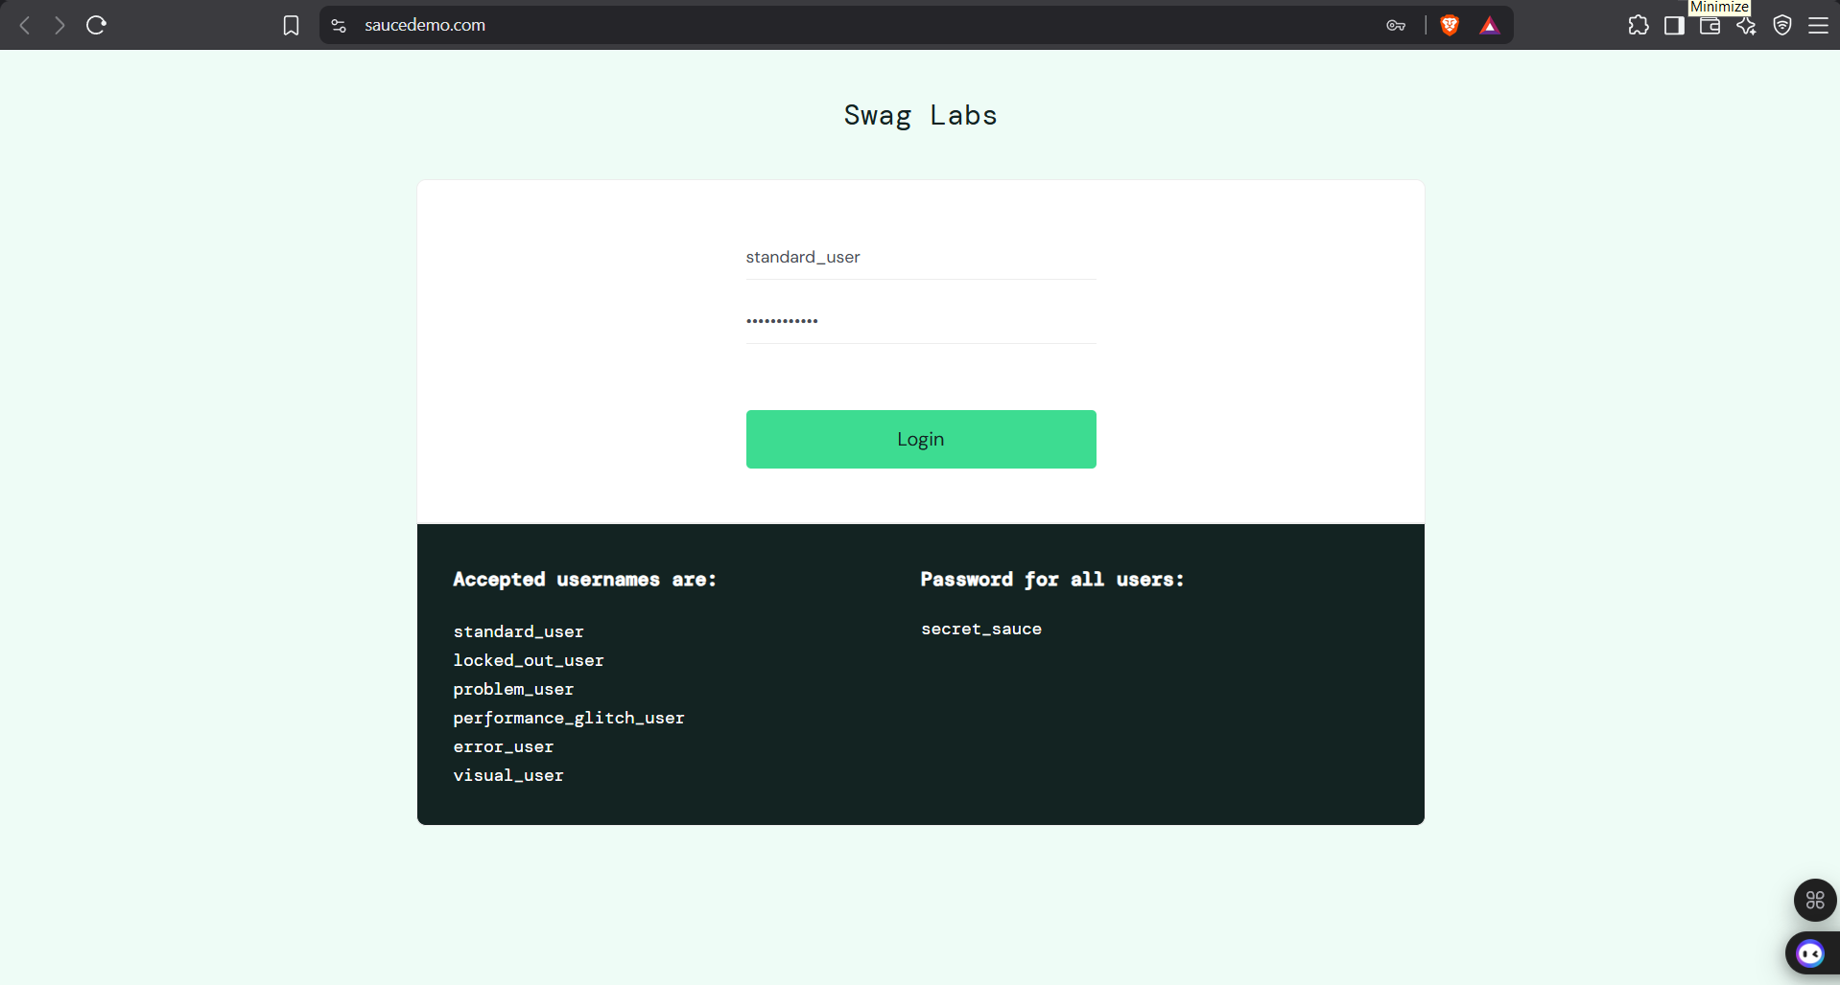
Scenario ID: 2b Login with locked_out_user
Scenario: Login with locked_out_user (negative test)
Test Steps:
1. Open login page
2. Enter Username: locked_out_user
3. Enter Password: secret_sauce
4. Click Login
Expected Result: Error message displayed: Epic sadface: Sorry, this user has been locked out.
Actual Result: Correct error message displayed. User remains on login page
Status: Pass
Scenario ID: 3a View Inventory / Products page
Scenario: View product list after successful login
Test Steps:
1. Login with standard_user
2. Observe the Products page
Expected Result: All 6 products displayed with name, description, price and Add to cart button
Actual Result: 6 products displayed correctly with images, prices and Add to cart buttons
Status: Pass
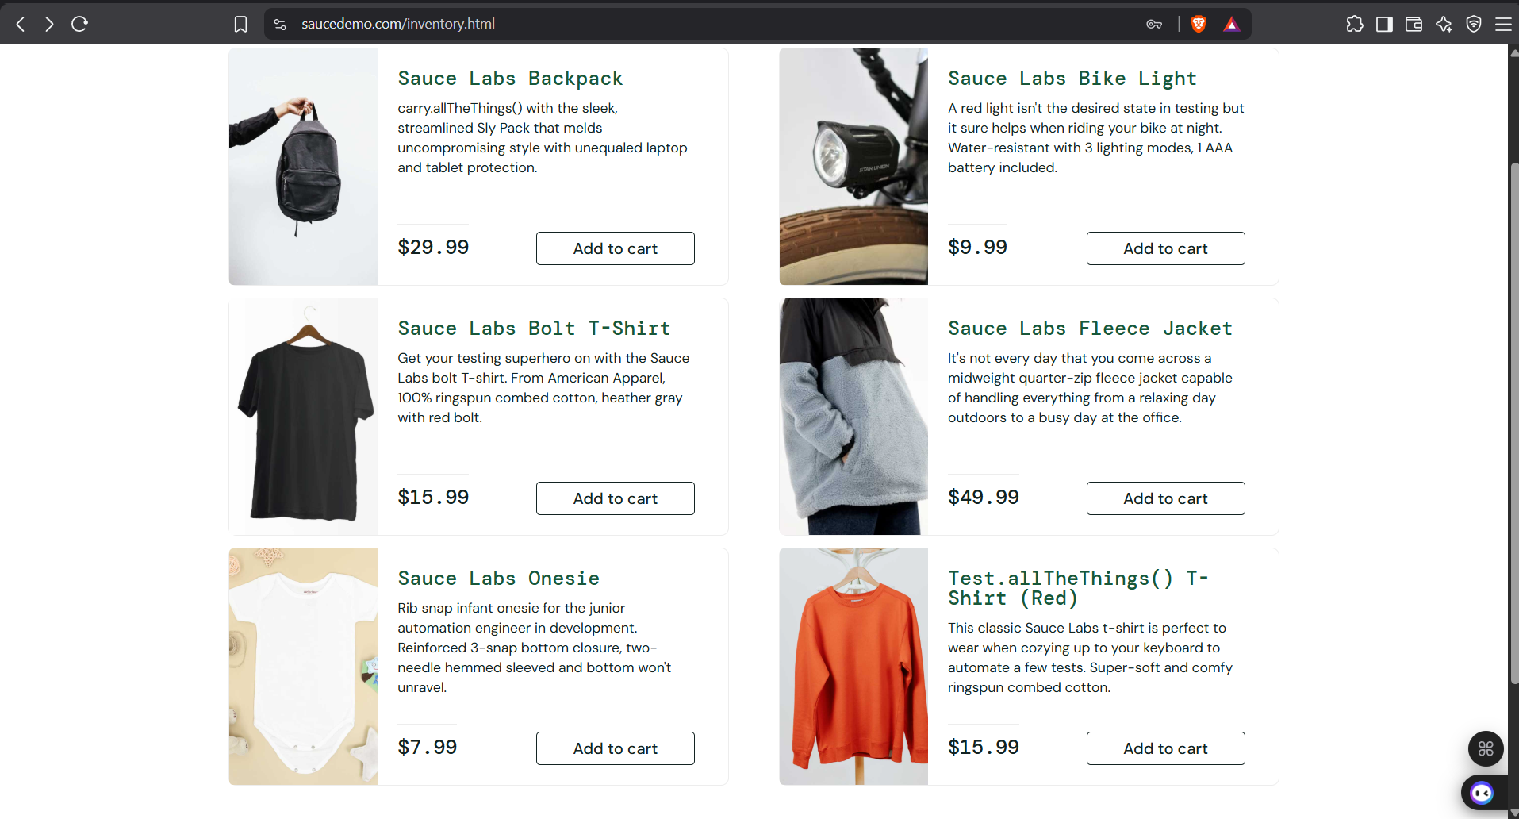
Scenario ID: 4b Add single product to cart
Scenario: Add Sauce Labs Bolt T-Shirt to cart from Inventory
Test Steps:
1. On Inventory page
2. Click "Add to cart" on Sauce Labs Bolt T-Shirt
3. Observe cart badge
Expected Result: Cart badge updates to 1 and button text changes to "Remove"
Actual Result: Cart badge showed 1. Button changed to Remove
Status: Pass
Scenario ID: 5c Open Product Detail page
Scenario: Navigate to product detail of Sauce Labs Bolt T-Shirt
Test Steps:
1. Click on Sauce Labs Bolt T-Shirt (name or image)
2. Observe the detail page
Expected Result: Product detail page opens with large image, full description, price, and Remove button. Back to products link available. Cart badge visible.
Actual Result: Detail page opened correctly with all elements. Cart badge = 1
Status: Pass
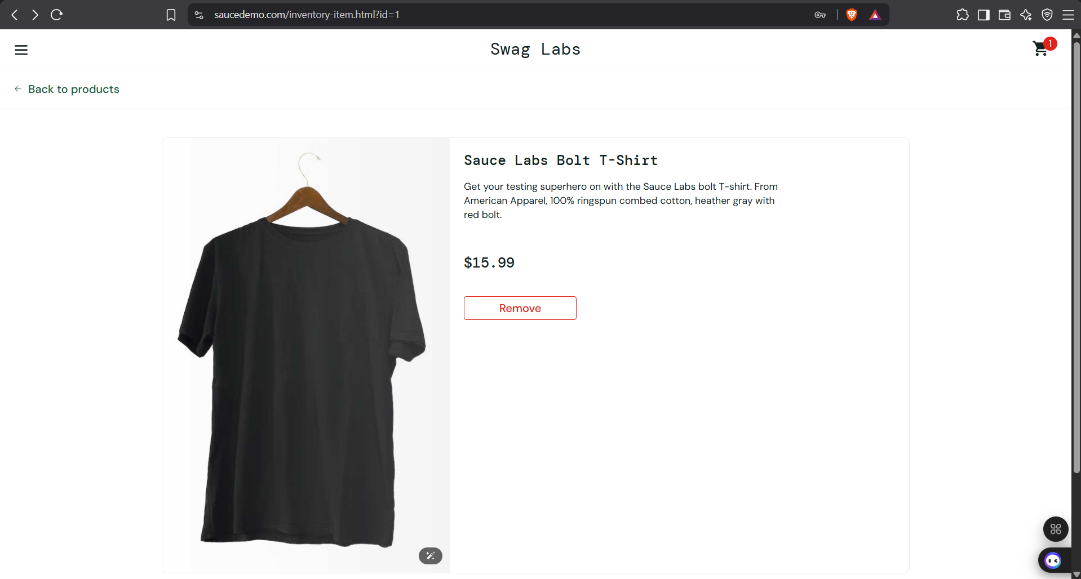
Scenario ID: 6d Add second product and verify cart badge
Scenario: Add Sauce Labs Backpack and verify cart badge updates to 2
Test Steps:
1. Click "Back to products"
2. Click "Add to cart" on Sauce Labs Backpack
3. Check cart badge
Expected Result: Cart badge updates to 2
Actual Result: Cart badge correctly updated to 2
Status: Pass
Scenario ID: 7e View Cart page with multiple items
Scenario: Verify cart contents with 2 products
Test Steps:
1. Click on Cart icon (top right)
2. Observe Your Cart page
Expected Result: Cart shows both products with QTY=1, correct prices, Remove buttons, Continue Shopping and Checkout buttons
Actual Result: Cart displayed both items correctly with accurate prices and quantities. Badge = 2
Status: Pass
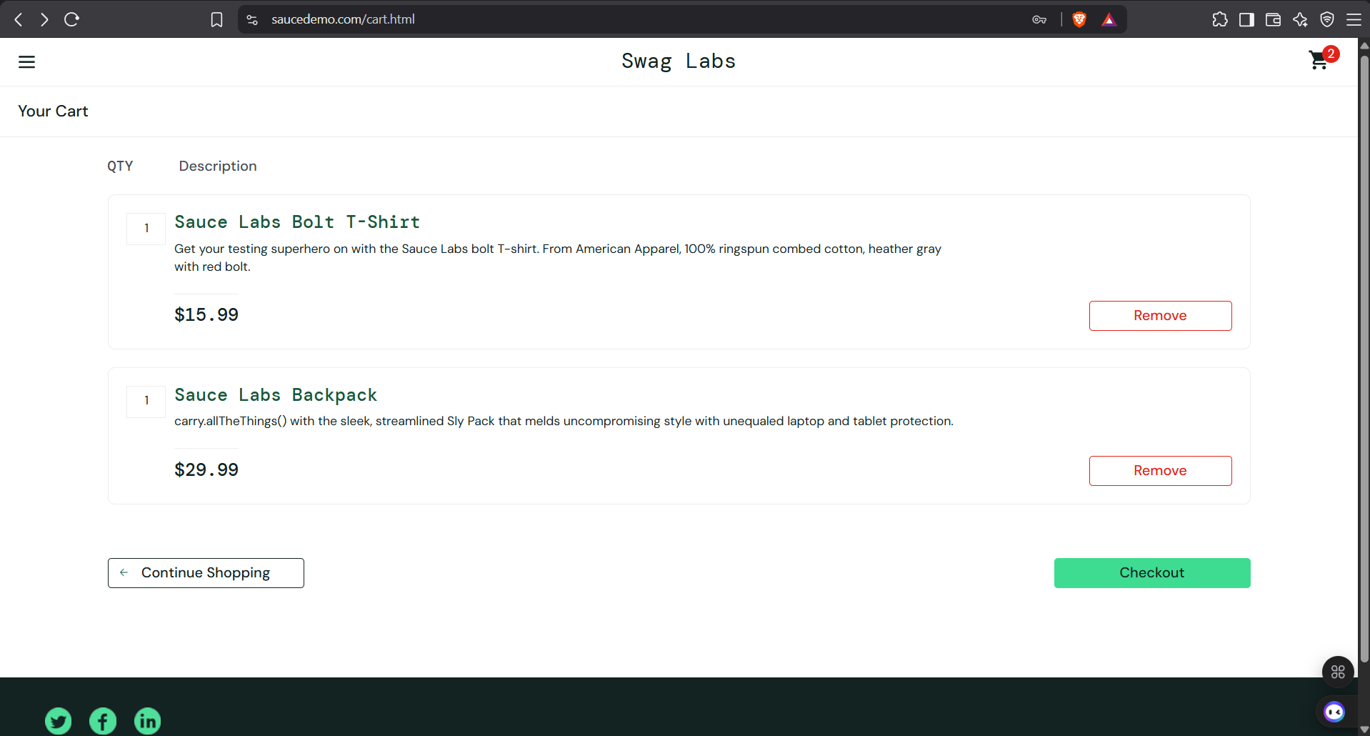
Scenario ID: 8f Remove item from cart
Scenario: Remove one item and verify cart badge updates
Test Steps:
1. On Cart page
2. Click Remove on one item
3. Observe list and cart badge
Expected Result: Selected item is removed. Cart badge decreases by 1
Actual Result: Item removed successfully. Cart badge updated correctly
Status: Pass
Scenario ID: 9a Proceed to Checkout – Your Information
Scenario: Start checkout flow from cart
Test Steps:
1. Ensure items are in cart
2. Click Checkout button
Expected Result: Redirected to Checkout: Your Information page with First Name, Last Name and Postal Code fields
Actual Result: Checkout Information page loaded correctly
Status: Pass
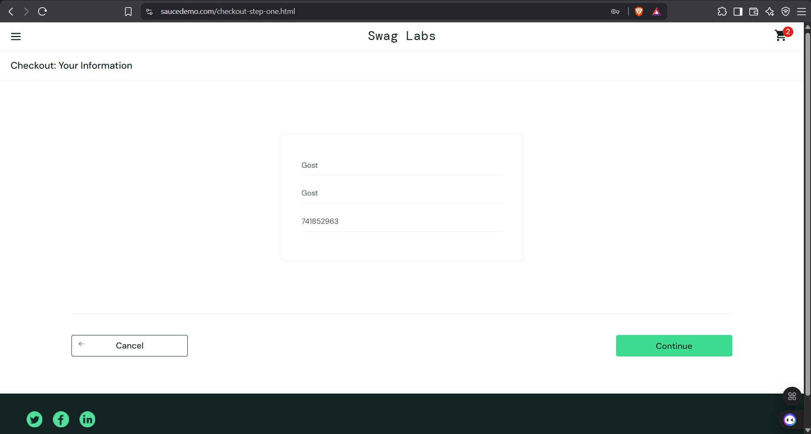
Scenario ID: 10b Fill Checkout Information and Continue
Scenario: Enter personal details and proceed
Test Steps:
1. Enter First Name: Gost
2. Enter Last Name: Gost
3. Enter Postal Code: 741852963
4. Click Continue
Expected Result: Redirected to Checkout Overview page showing items, payment info, shipping info and price total
Actual Result: Successfully moved to Overview page with correct item list
Status: Pass
Scenario ID: 11c Verify price calculation on Overview page
Scenario: Review order summary and price total
Test Steps:
1. On Checkout Overview page
2. Verify Item total, Tax and Total
Expected Result: Item total = $45.98 | Tax = $3.68 (8%) | Total = $49.66
Actual Result: Item total: $45.98 | Tax: $3.68 | Total: $49.66 — calculation is correct
Status: Pass
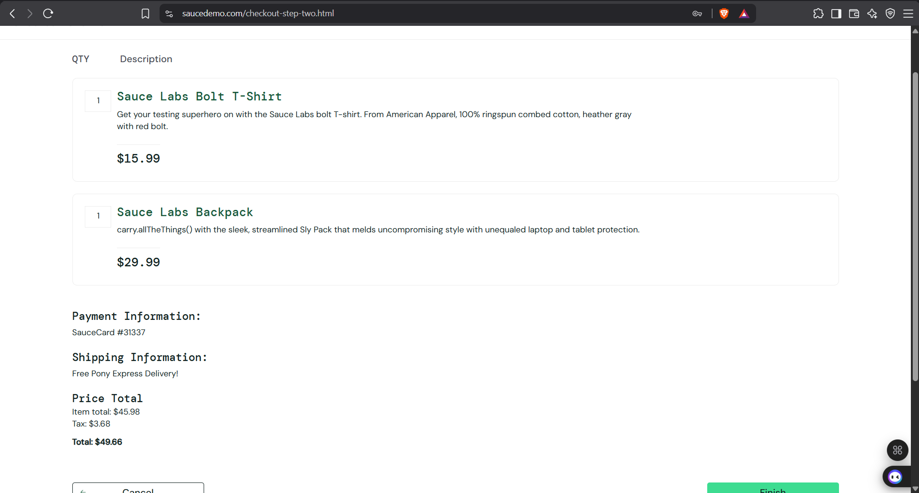
Scenario ID: 13d Complete the order (Finish)
Scenario: Place the order successfully
Test Steps:
1. On Overview page
2. Click Finish button
Expected Result: Redirected to Checkout Complete page with success message "Thank you for your order!"
Actual Result: Order completed successfully. Thank you message + Back Home and Generate PDF buttons shown
Status: Pass
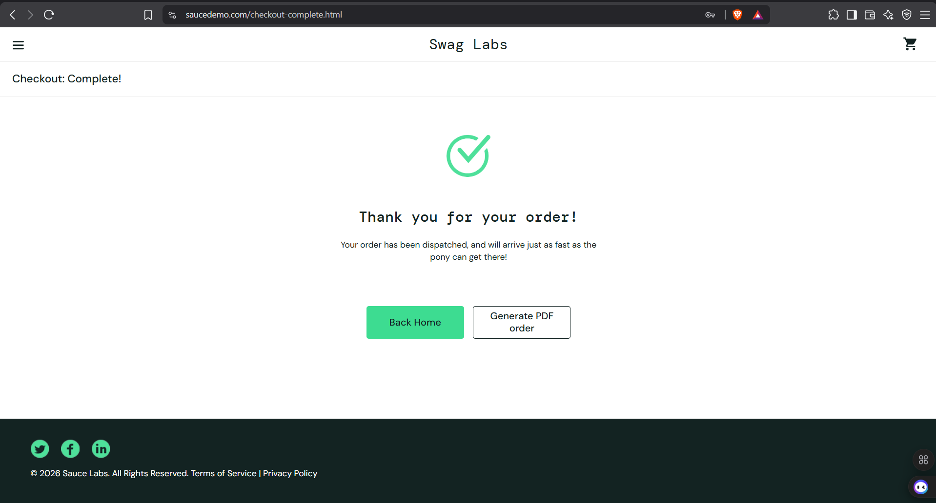
Scenario ID: 13a Access Checkout Complete page without login
Scenario: Attempt to access protected page without authentication
Test Steps:
1. Logout or open a new browser session
2. Directly navigate to https://www.saucedemo.com/checkout-complete.html
Expected Result: User is redirected to Login page with error message preventing unauthorized access
Actual Result: Error shown: Epic sadface: You can only access '/checkout-complete.html' when you are logged in.
Status: Pass
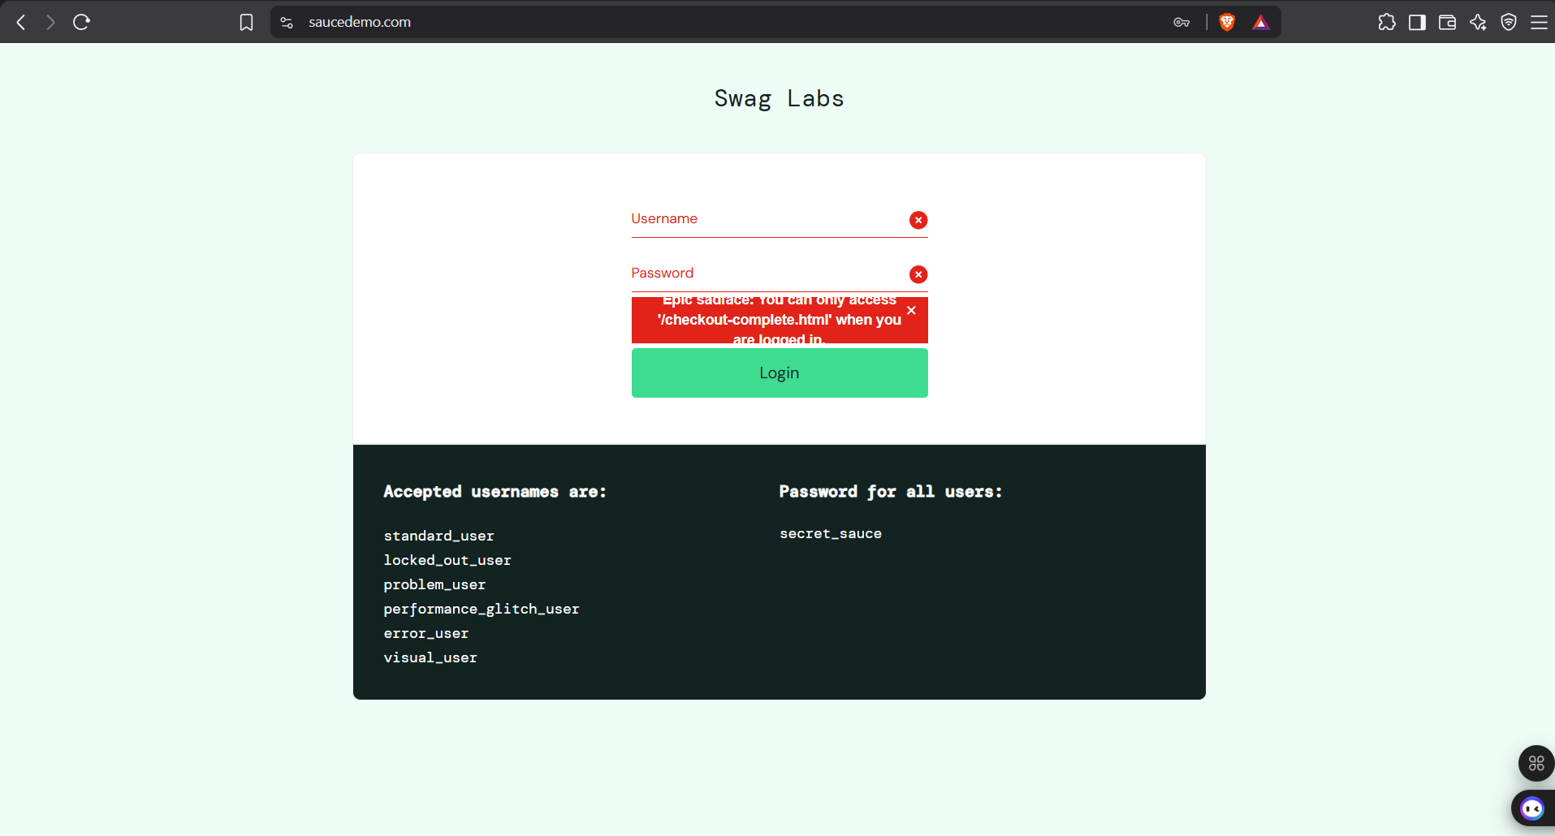
Scenario ID: 14b Attempt to access checkout without login (repeat)
Scenario: Confirm protected route behavior
Test Steps:
1. Open a new browser session (logged out)
2. Directly navigate to https://www.saucedemo.com/checkout-complete.html
3. Observe the response
Expected Result: User is redirected to Login page with the same error message
Actual Result: Redirected to Login page correctly. Exact error shown confirming protected route.
Status: Pass
Summary Of Test Results
Total Test Cases: 14
Passed: 14
Failed: 0
Pass %: 100%
Conclusion and Recommendations
Pass Rate: 100%. All 14 test cases passed. Login, inventory, cart, checkout and security flows are working as expected based on the captured screenshots.
Key Observations:
• Login (valid & locked_out_user), product browsing, cart management, checkout information, overview and completion flows are working as expected.
• Price calculation (Item total $45.98 + Tax $3.68 = Total $49.66) is accurate.
• Cart badge state is maintained correctly across Inventory, Product Detail and Cart pages.
• Protected routes correctly redirect unauthenticated users to the login page with an appropriate error message.
• UI is clean, consistent and user-friendly on all tested pages.
Recommendations:
• Continue testing with other users (problem_user, performance_glitch_user, error_user, visual_user) to uncover additional defects.
• Perform cross-browser and mobile responsive testing.
• Add negative test cases for checkout form validation (empty fields, invalid postal code, etc.).
Bug Reports
No critical defects found in the current test cycle based on the provided screenshots.
Note: Earlier test runs had reported a possible off-by-one cent rounding issue ($49.65 vs $49.66). Current verification with the same product combination (Bolt T-Shirt $15.99 + Backpack $29.99) shows correct Total of $49.66.

